COMSATS University Islamabad

Applications of Information and Communication Technologies

Lab No. 03

Introduction to MS Excel

|  |  |
| --- | --- |
| Name | Ali Haider |
| Registration Number | FA24-BCE-018 |
| Class | CS101- AICT |
| Instructor’s Name | Khuram Ali |

**Date : 1st-october -2024**

**PART 01:**

**The Sales Invoice:**

**Objective:**

The primary goal of this lab is to gain proficiency in using MS Excel, enabling us to create and manage Excel documents effectively.

**Equipment:**

The following equipment are used

* MS Excel
* MS Word

**Steps to Complete the Sales Invoice:**

Following are the steps that we follow to Complete the Sales Invoice:

1. List a minimum of 4 items along with their corresponding quantities, list prices, and discounts.
2. Determine the discounted price for each item by subtracting the discount from the list price and enter the result in the "Your Price" column.
3. Compute the total price for each item by multiplying the "Your Price" by the "Quantity."
4. Sum all the item totals to calculate the Subtotal.
5. Calculate the General Sales Tax (GST) at a rate of 17% of the Subtotal.
6. The Amount Due will be the sum of the Subtotal and GST.

**Formulas:**

1. Your Price = List Price - Discount
2. Total = Your Price × Quantity
3. Subtotal = Sum of all Totals
4. GST = Subtotal × 0.17
5. Amount Due = Subtotal + GST

**Excel Work:**

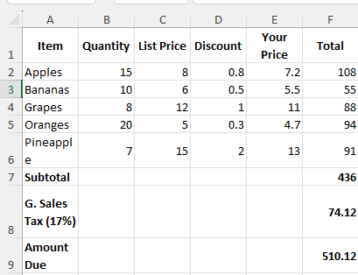

**Lab Task 3:  
 Class Make-up:**

**Objective:**

1. Create a pie chart to display the distribution of students across different school years.
2. Generate a pie chart illustrating the gender breakdown within the class.
3. Calculate the percentage of students who completed the homework and represent it visually using a pie chart.

**3. Procedure:**

**Step 1: Collect and organize data for the class make-up:**

* **Number of students by year**:
  + Freshmen: 10
  + Sophomores: 8
  + Juniors: 4
  + Seniors: 1
  + Did not respond: 5
* **Gender distribution**:
  + Men: 11
  + Women: 17
* **Homework completion**:
  + Completed homework: 23 students
  + Did not complete homework: 5 students

**Step 2:** Create pie charts for each category.

**Step 3:** Calculate the percentage of students who completed the homework.

**Excel Work:**

Class Composition by Year:

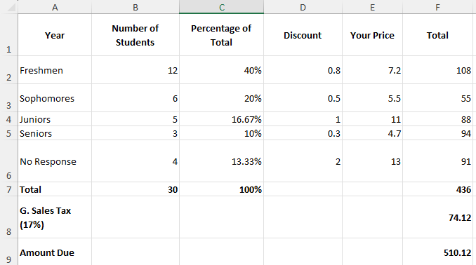

**Pie Chart:**

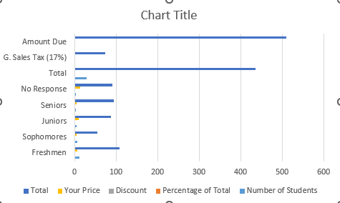

**Gender Distribution:**

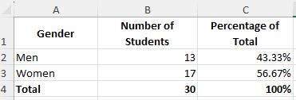

Pie Chart:

Homework Completion:

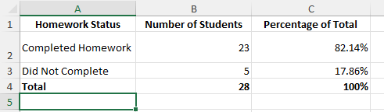

**Pie Chart:**

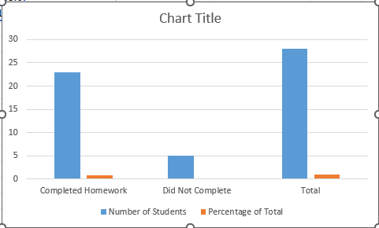

**LAB Task 4:**

**Vacation Budget:**

**Destination:** I would love to visit Sydney. It’s a lively city famous for its beautiful beaches, iconic landmarks, and vibrant arts scene.

**Activities:**While in Sydney, I would love to:

* Visit the Sydney Opera House and take in its architectural marvel.
* Explore the Royal Botanic Garden for a peaceful escape within the city.
* Stroll through The Rocks district and discover its historical significance.
* Spend an afternoon at Bondi Beach for a classic Australian beach experience.
* Enjoy a sunset cruise along Sydney Harbor to see the city’s skyline from the water.
* Shop at the local markets for unique Australian souvenirs and handmade crafts.

**Proposed Budget:**The total estimated budget for this vacation is $3,500. This includes transportation, accommodations, meals, activities, and a 15% contingency for unexpected expenses.

**Excel Work Sheet:**

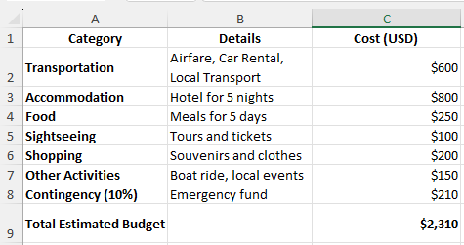

**Conclusion:**

These lab activities highlighted the significance of precision, organization, and the utilization of tools such as spreadsheets and charts for managing financial and statistical data. They have provided me with vital skills that are crucial in both professional and personal contexts, improving my capability to navigate real-world situations with effectiveness and clarity.